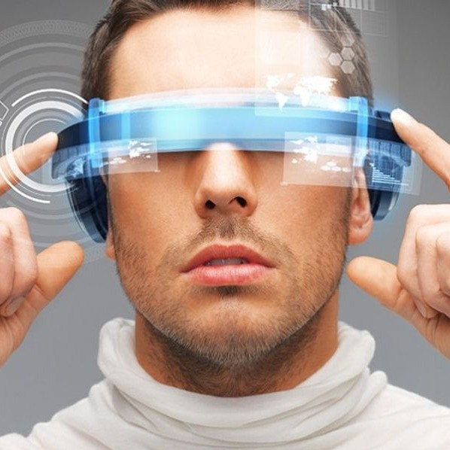TECHNOLOGY AND INVENTIONS

# Describing technology

**1**

## Study the adjectives and put them into the correct category below.

|  |  |  |  |
| --- | --- | --- | --- |
| **convenient** | **cutting-edge** | **handy** | **impractical** |
| **indispensable** | **invaluable** | **obsolete** | **outdated** |
| **powerful**  Positive adjectives: Convenient, indispensable, powerful, invaluable, state-of-the-art, handy, cutting-edge | **state-of-the-art** | **useless** | **worthless** |

Negative adjectives: Obsolete, useless, impractical, outdated, worthless

## Look at the inventions below.

|  |  |  |  |
| --- | --- | --- | --- |
| the Internet | the telegraph | the typewriter | Facebook |
| bicycles | the train | the light bulb | ﬁlm cameras |

**Discuss how useful they are with your partner using some of the adjectives above and expressions below.**

*Without it/them, we wouldn’t be able to ...*

*It’s/They’ve become indispensable/totally outdated*

*...*

*We couldn’t manage without it/them. I think we can get by without it/them.*

*It’s/They’re no longer considered to be ...*

*It’s/They’re still considered to be ...*

*It/They used to be considered ...., but it’s/they’re now ...*

# Vocabulary

**2**

## Match the underlined words to their deﬁnitions below.

1. D) Using a translation app on your mobile device can really enhance your travel experience.
2. C) I don’t need a watch. I can just glance at my smartphone to check the time.
3. A) The company launched a pilot scheme to see how people would use the new product.
4. G) This app helps me transcribe songs that I can’t understand.
5. E) This new tool seamlessly integrates with your Google Calendar.
6. B) The scientist made an astonishing new discovery. Everyone was shocked.
7. F) In the past, people felt very self-conscious using mobile phones in public.
   1. a small-scale experiment to decide how and whether to launch a full-scale project
   2. extremely surprising
   3. look at something very quickly
   4. make better
   5. smoothly and continuously, without being noticed
   6. uncomfortably nervous about or embarrassed by what other people think about you
   7. write down something that is spoken

# Reading

**3**

## You are going to read an article from 2014 on Google Glass, a state-of-the-art invention that later turned out to be a failure as a consumer product. Study the list of features and uses below and tick the ones that are mentioned in the text.

mapping guidance (FALSE)

voice recognition (TRUE)

medical advice (FALSE)

live translation (TRUE)

appointment booking (FALSE)

video/image transfer (TRUE)

video player (TRUE)

music recognition (TRUE)

weather updates (FALSE)

**Could Google Glass be the future of tourism?**

## We’re all familiar with the value a smartphone can oﬀer when we travel, from city guides to currency converters. But what’s the next big thing?

Well, it could be Google Glass — the wearable tech that sits on your face like regular spectacles but has a tiny screen just above your eye level and connects wirelessly to your smartphone. Google Glass has just gone on sale in the UK — at £1,000 a pair. One travel company, holidaysplease.co.uk, is lending Google Glass to selected customers. So, is it something that can enhance your holidays?

First, take note: wearing the lensless Google Glass makes you feel self-conscious. Glass doesn’t fold ﬂat like regular specs, so once it’s on, you’re stuck with it.

The screen is tiny, but big enough to see plainly when you glance upwards. So, for instance, you can use Glass as a mapping guide. It uses your smartphone’s GPS sensor and displays directions with a 3D map. The right arm of the glasses has a speaker in it and a voice tells you when to turn. This is one of the most powerful uses of Google Glass, and it’s smoothly, seamlessly done.

But there are other interesting features. You can speak to the device with commands like "OK Glass, take a photo" or "OK Glass, record a video". You can also send photos and videos to friends by email. More usefully, the astonishing live translation app Word Lens is available on Google Glass. Choose the command "translate this" and the Spanish sign in front of you is transcribed into English on screen.

It’s not just useful for travellers — Copenhagen airport staﬀ are using them and Virgin Atlantic ran a pilot scheme this spring where Upper Class passengers were greeted by staﬀ using Glass to check them in, give them weather updates, translate foreign-language text and so on.

So, do you need them? In my test, getting past the self-conscious stage was a challenge. Using the translation app was great, as was Shazam ("OK Glass, recognise this" to identify the music playing). And sending photos by email or reading incoming text messages was easy. But let’s remember that you’ll probably be using Glass abroad and for all these functions you need a mobile phone data connection, which almost certainly means expensive roaming charges.

Even so, Google Glass is fun, and oﬀers genuinely useful technologies. Future versions that have better screens (it is hard to read in bright sunshine) will be worth a try.

*Adapted from The Independent, by David Phelan, 07 July 2014*

# Talking point. Writing.

**4**

## Discuss the questions below.

1. What are the advantages and disadvantages of Google Glass?

They are innovative, but they need internet connection and a phone is just better.

1. Why do you think this product did not become successful?

Because the phones are more practical.

1. Would you like to wear Google Glass now? Why/why not?

I would wait until I can implant an UI in my glasses, like in Cyberpunk 2077.

# Technology idioms

**5**

## In pairs, study the underlined idioms below. Match them to the deﬁnitions.

1. E) Joe is very touchy. It’s really easy to push his buttons!
2. B) Mark and Patrick agree on everything. They are always on the same wavelength.
3. C) Come on, it’s only a crossword. It’s not rocket science.
4. D) I wrote down Tuesday in my diary, but Jane thought we were meeting on Wednesday. Some how we got our wires crossed.
5. A) This new mobile device is light years ahead of everything else.
6. G) Just copy what everyone else is doing. There’s no need to re-invent the wheel.
7. I) The new website is already up and running.
   1. a long way in front in terms of development
   2. have the same ideas and opinions about something
   3. It’s not diﬃcult to understand.
   4. misunderstood each other
   5. provoke a reaction
   6. ready for use
   7. waste time doing something that has already been done in an eﬀective way

# Talking point. Write the answers and we will discuss them in class.

**6**

## Discuss any of the questions below.

1. What are the most useful apps on your smartphone?

WhatsApp for communication with other people, and Youtube and Reddit for entertainment.

1. Do you like to keep up-to-date with the latest gadgets?

I don’t need to be up-to date. I changed phone recently, and my last phone was outdated in 2018.

1. Do you think the development of mobile technology is a good or bad thing?

Is a good thing, but there are bad techniques for the customer that certain companies does.

1. How has your life changed in recent years as a result of new technology?

I have a little more social life, and im more entertained in general.